"SYSTEMATIC LITERATURE REVIEW OF APPLICATIONS OF DATA SCIENCE TECHNIQUES IN THE DOMAIN OF INDIAN STOCK MARKETS WITH A FOCUS ON IDENTIFYING INVESTOR OPPORTUNITIES"
Research Paper

Sulekha Aloorravi, Swiss School of Business and Management, Geneva, Switzerland, sulekha@ssbm.ch
Prof. Dr. Vijayakumar Varadarajan, Swiss School of Business and Management, Geneva, Switzerland, vijayakumar@ssbm.ch

“Abstract”
Any investment model relies on capital for the investment to grow. The investment model such as Indian stock market relies on public to invest their savings and the investments thus acts as a source for the growth of both the individual investor and the country’s economy. In India, a very small proportion of the population invests in stock markets while there is a large proportion with capital and do not invest due to the lack of adequate knowledge or due to the lack of adequate understanding on how to utilize the public information available on the markets. In this study, the scope is to perform a systematic literature review to understand what level of analytics and applications of data science are available for individuals to understand how publicly available data can be used along with data science techniques on stock markets.
Keywords: Opportunity Cost, Stock Market, Machine Learning, Deep Learning.

Methodology Adopted to Perform this Literature Review

1.1 Search tokens
Systematic literature review for this research started by searching and exploring for existing research articles on the following search tokens in google scholar:
- Machine learning in stock market
- Deep learning in stock market
- Data Science in stock market
- opportunity analysis in stock markets
- stock market
- Indian stock market analysis
The overall landscape of research materials on the search tokens are distributed as follows:
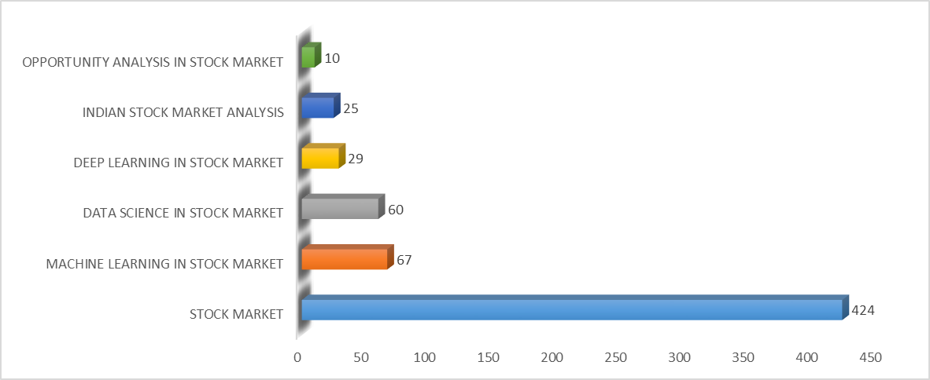
Figure 1.1 Total research papers by search strings

1.1.1 Search criteria 1
There were around 10 research materials and existing literature available on the concept covering opportunity analysis in stock markets that also covers string combinations such as opportunity + stock + market and opportunity analysis + stock + market.

1.1.2 Search criteria 2
There were around 25 research materials and existing literature available on the concept covering Indian stock market analysis that also covers string combinations such as Indian + stock + market, Indian + stock + analysis, Indian + market + analysis and Indian + stock + market + analysis.

1.1.3 Search criteria 3
There were around 29 research materials and existing literature available on the concept covering deep learning in stock market that also covers string combinations such as deep + learning + stock, deep + learning + stock + market and deep + learning + market.

1.1.4 Search criteria 4
There were around 60 research materials and existing literature available on the concept covering data science in stock market that also covers string combinations such as data + science + stock, date + science + stock + market and data + science + market.

1.1.5 Search criteria 5
There were around 67 research materials and existing literature available on the concept covering machine learning in stock market that also covers string combinations such as machine + learning + stock, machine + learning + stock + market and machine + learning + market.

1.1.6 Search criteria 6
The last, wider and the most generic search criteria was to find out all possible existing literature on stock markets or capital markets. There were around 424 research materials and existing literature available on the concepts covering stock market that also covers string combinations such as stock + market, capital + market and market + investment.
The preceding statistics is based on the search tokens and the relevance of these gathered materials will further be discussed in the upcoming sections.
The publishers of the gathered research materials will be analyzed further.

1.2 Publisher analysis
A total of 615 existing literature in the form of research papers, journals and books were collected and reviewed to understand the relevance of the existing literature by analyzing them in relation to my research in scope.
The total number of research papers by publishers are listed as follows:
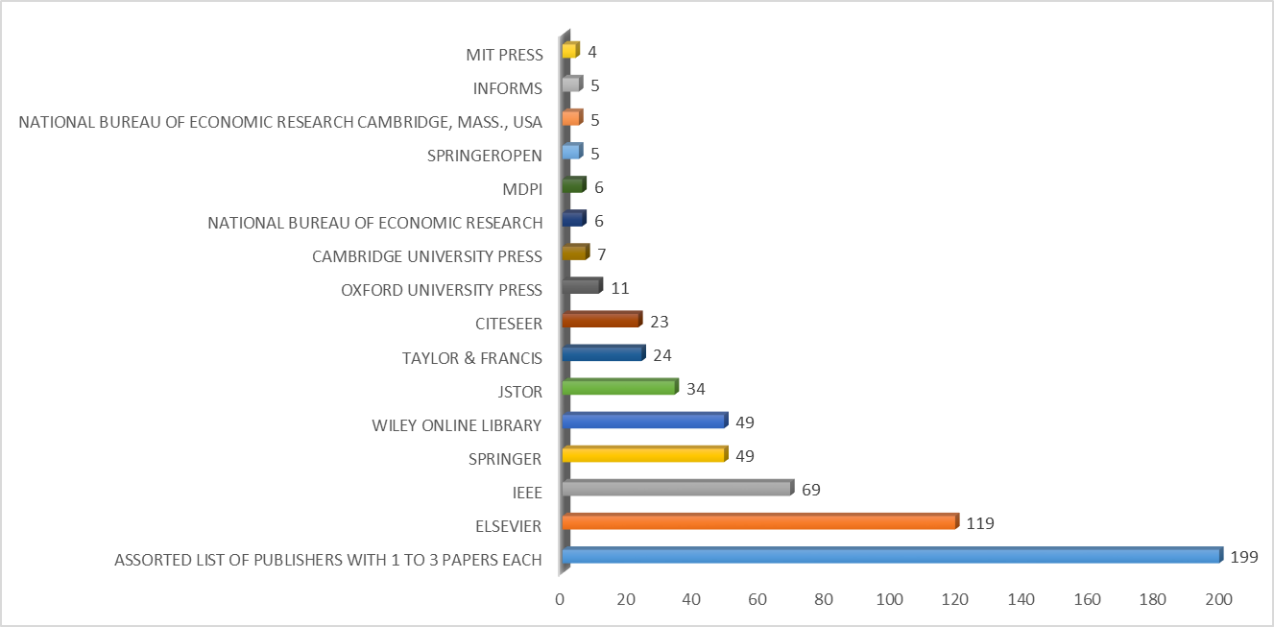
Figure 1.2 Total research papers by publishers
The research papers covering the search tokens for this research are majorly published by Elsevier, IEEE, Springer, Wiley online library which covers journals on finance and JSTOR which covers journals of business. In the Figure 1.2, there is also an assorted list of multiple publishers that covers around a range of 1 to 3 research articles each. Our focus of study is mainly on the articles published by Elsevier, IEEE, Springer, Wiley online library and JSTOR.
The relevance of these 615 research papers and journals in relationship to the research in scope will be analyzed further.

1.3 Relevance to research topic
The abstract, methodology and conclusion of the 615 research papers identified for this literature review are studied to understand its relevance to the research in scope. Post analysis, it is identified that 407 research papers gathered were not relevant to the research topic under study and 208 have relevance from at least one perspective. The relevance of topics is represented as follows:
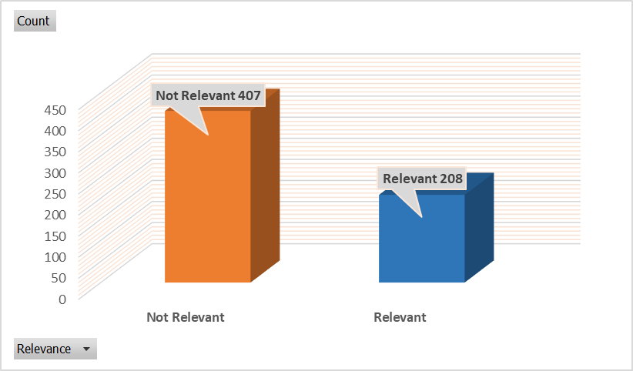
Figure 1.3 Total research papers by relevance
The relevant papers were further reviewed, and the statistics is listed down in the order of their respective publishers.
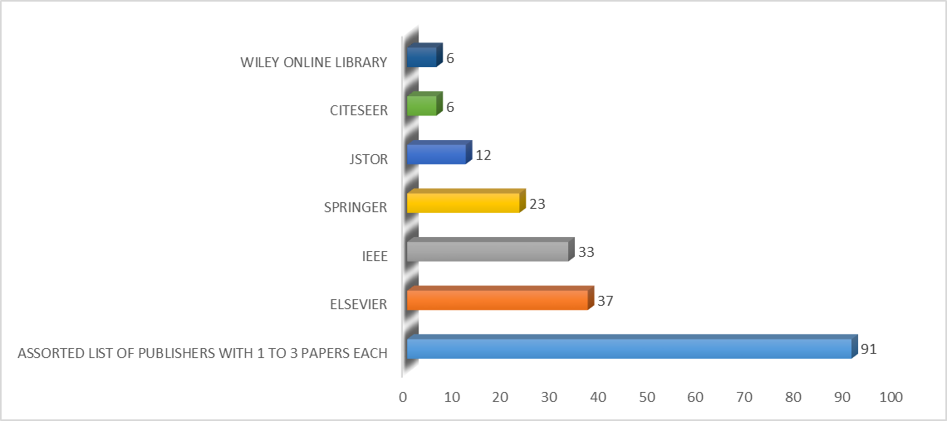
Figure 1.4 Total relevant research papers by publishers
The research papers covering the relevance for this research are majorly published by Elsevier, IEEE, Springer, JSTOR which covers journals of business, and Citeseer and Wiley online library which covers journals on finance. In the Figure 1.4, there is also an assorted list of multiple publishers that covers around a range of 1 to 3 research articles each. Our focus of study is mainly on the articles published by Elsevier, IEEE, Springer, JSTOR, and Citeseer and Wiley online library.
The number of citations of the relevant literature will be analyzed further.

1.4 Citation analysis
Number of citations on a research paper denotes the recognition of a research in that particular field and a possible implementation of the concepts and a higher scope for enhancements. Analyzing the citations of various literature gathered for this research is the next important step of this literature review.
Top 20 research titles with their corresponding number of citations are represented as follows.
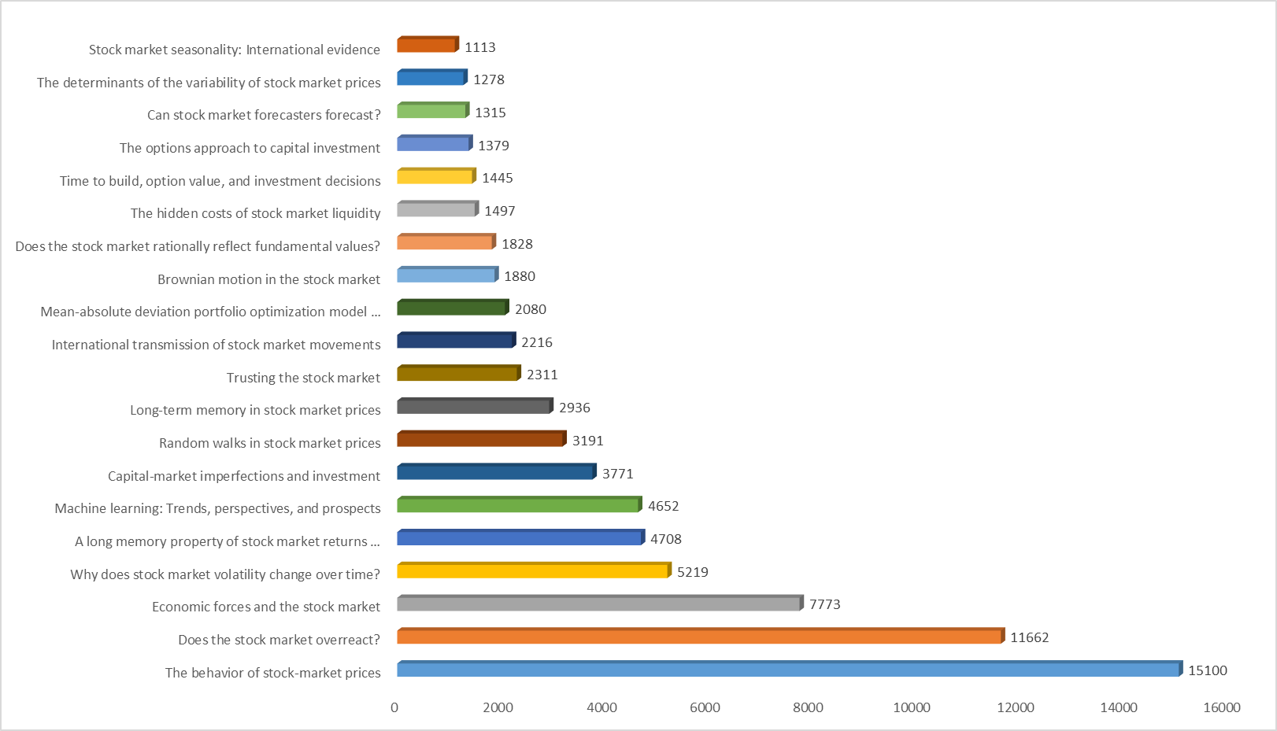
Figure 1.5 Top 20 most cited relevant papers
The literature citations are further analyzed by reviewing the statistics by publisher in the Figure 1.6. The maximum number of aggregated citations were on the papers published by JSTOR which publishes journals for business followed by Wiley online library which publishes journals for finance. This list is further followed by Elsevier, IEEE, Springer and Citeseer in a descending order.
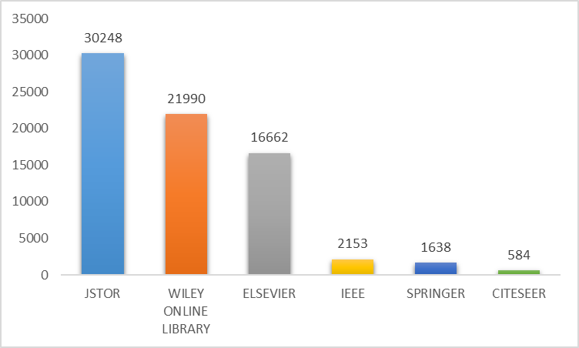
Figure 1.6 Total number of citations of relevant papers by publisher
The chronology of publications with relevance to the year of publishing will be analyzed further.

1.5 Chronology of publications
The greatest number of citations were from JSTOR and Wiley online library as mentioned in the Figure 1.6. The relevant literature from these publishers were further analyzed to identify how recent the research was.
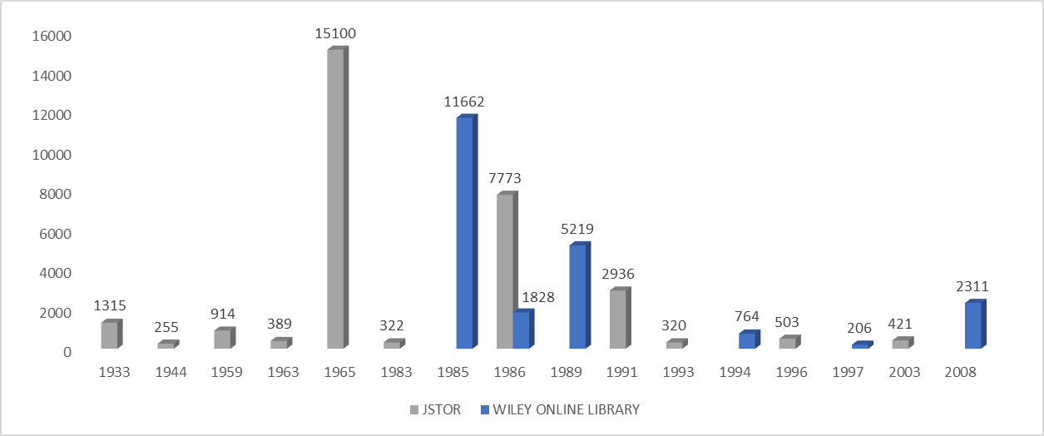
Figure 1.7 Top publisher citations of relevant papers by year
All the research papers of JSTOR and Wiley that were identified as relevant papers by studying their abstract, methodology and conclusion happens to be published between the years 1933 to 2008. This indicates that there were no recent papers or journals from these publishers that can be shortlisted for this research. However, the already shortlisted papers will still be studied while synthesizing research questions based on the knowledge that can be derived from these papers and journals.
The most recent journal publishers were further analyzed for the number of citations.
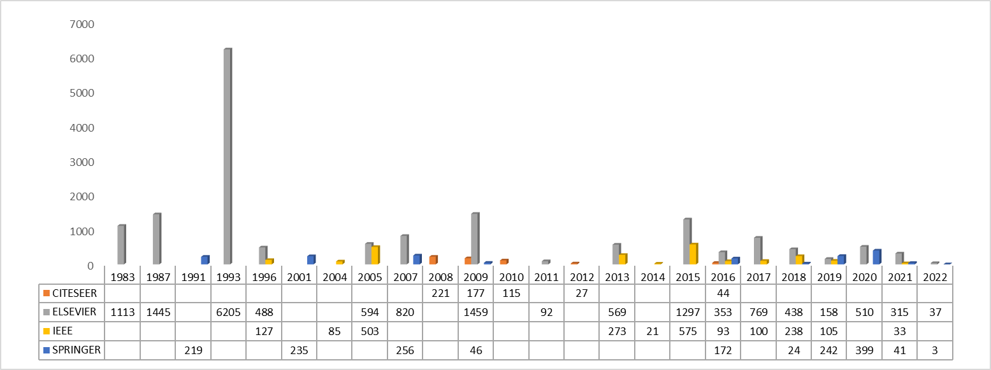
Figure 1.8 Publisher citations of relevant papers by recent time period
Elsevier, IEEE and Springer have the greatest number of citations on literature that were published between 2001 and 2022.
With these initial efforts to identify, analyze, review and shortlist the most relevant, most cited, highly reputed and fairly recent literature, further analysis will be performed to synthesize the research questions.

2. Research Topics
The research topics are divided into three main concepts as defined below and the related research is synthesized under each concept.
1. Understanding the importance of opportunity cost in investments.
2. Exploring the applications of data science in the field of investment analysis.
3. Comprehending the key features considered in the study of investment decision making.

2.1 Understanding the importance of opportunity cost in investments
The first part of this research is to analyze the importance of opportunity cost in investment choices by examining existing literature and to assess on how the existing literature can be studied, applied or extended further to carry forward by analyzing them against the problem statements of this research in scope.
The opportunity cost has been studied and discussed in some of the prominent journals or research papers. For this research sub question, 7 of the relevant research papers have been selected for this study and after analyzing in detail, 3 out of 7 had some relevance with respect to this specific research and are studied further.
Timing is very critical when it comes to decision making and it is even more significant when the decision is related to an investment. When both money and timing are dependent variables of an investment decisions, the decision need to be made faster and also accurate. This leads to a situation of dilemma since a decision with a time limit can also go wrong.
Decision-making dilemmas can arise because errors may result either from deciding too soon or from delaying decisions too long. Delay can result in lost opportunities or reductions in payoffs from the most accurate decision (Payne et al., 1996).
The opportunity cost by its definition is well explained in (Buchanan, 1991) as the anticipated value of 'that which might be' if choice were made differently. Note that it is not the value of 'that which might have been' without the qualifying reference to choice. In the absence of choice, it may be sometimes meaningful to discuss values of events that might have occurred but did not. It is also explained further that… First, if choice is made among separately valued options, someone must do the choosing. That is to say, a chooser is required, a person who decides. From this the second implication emerges. The value placed on the option that is not chosen, the opportunity cost, must be that value that exists in the mind of the individual who chooses.
It is also explained in the paper that the decision impact of opportunity costs is of interest to accountants, economists, and behavioural scientists. From an economic point of view these costs are generally considered relevant, and explicitly reporting them for decision making could improve the quality of future decisions (Hoskin, 1983).

2.1.1 Study 1 - Literature
What were the problems studied or researched?
The first study focuses on investigating decision making under situations where there is opportunity-cost time pressure. The authors were interested in how people adapt their decision-making strategies when faced with opportunity-cost environments and in the possible limits or even failures in adaptivity that may arise in such environments. In particular, they focused on how people decide when there are conflicts between the processing implications of opportunity costs and the implications of other variables such as goals and the degree of conflict (intercorrelation) between outcomes(Payne et al., 1996).
What methodologies were applied to solve the problem?
The adaptive decision maker: an effort/accuracy framework is discussed in this literature. Stronger tests of the effort/accuracy framework have been conducted by using computer simulations of the effort and accuracy characterizing typical decision strategies to generate hypotheses about processing patterns and then carrying out experimental studies of actual decision behavior to test these hypotheses. The focus of these experiments was how opportunity-cost time pressure, along with variations in goals and context factors, influences the details of decision processing. Thus, the authors utilized a computerized system for collecting process-tracing data as well as choice data.
What type of data is used to understand opportunities?
The subjects’ information acquisitions, response times and choices were monitored using the Mouselab software system. Probabilities and pay offs were captured for various scenarios and outcomes using this software.
What were the opportunities for future work?
The results of the research imply that strategy changes are needed under opportunity-cost time pressure. In particular, when deciding in high-velocity environments, the decision maker should focus on breadth of evaluation rather than on depth of evaluation. More research that directly examines how alternative prescriptions for decision making fare in high- and low-velocity environments is needed (Payne et al., 1996).
Critical Analysis
The time criticality of decision making is more relevant and directly correlated in cases of market investment decisions since there is always a time factor involved for investors either when a decision needs to be made for buying, selling or holding a security or when a decision needs to be made on investing in the markets itself.
All of these decisions come with a cost, and it is the cost of losing an opportunity or delaying an opportunity which in turn can be derived as the opportunity cost. It is also to be noted that the data used for this study comes from a simulated environment which gives an opportunity to study the behaviour of real-life data with additional parameters.

2.1.2 Study 2 - Literature
What were the problems studied or researched?
The second study focuses on opportunity cost and choice. The most important consequence of the relationship between choice and opportunity cost is the ex-ante or forward-looking property that cost must carry in this setting. Opportunity cost, the value placed on the rejected option by the chooser, is the obstacle to choice; it is that which must be considered, evaluated, and ultimately rejected before the preferred option is chosen. Opportunity cost in any particular choice is, of course, influenced by prior choices that have been made, but with respect to this choice itself, opportunity cost is choice-influencing rather than choice-influenced (Buchanan, 1991).
What methodologies were applied to solve the problem?
The research in the research is not focused on data collection and analysis. It is rather theoretical and focused on explaining the implications of opportunity cost in decision making through economic principals and thought experiments (Buchanan, 1991).
What type of data is used to understand opportunities?
The data collection process is not employed in since the author focused on explaining the theoretical aspects of opportunity cost by presenting a conceptual framework that combines economic theory, rational choice theory, and the study of individual preferences and trade-offs (Buchanan, 1991).
What were the opportunities for future work?
With the familiar statement that 'sunk costs are irrelevant', economists acknowledge that the consequences of choices cannot influence choice itself. On the other hand, by their formalized constructions of cost schedules and cost functions, which necessarily imply measurability and objectifiability of costs, economists divorce cost from the choice process.
Critical Analysis
One of the strengths of this study is its focus on the theoretical concepts that influences opportunity cost. Similar to time, choice also is an important variable, rather a categorical variable, in investment decision making. Choice also influences the opportunity cost. Opportunity cost varies depending on the choice that was made, and it can either be directly or inversely correlated to the cost and in turn influences the decision-making process.
However, the lack of data collection process and empirical studies becomes a limitation to this study and provides an opportunity to explore further by gathering data that supports the theory behind the framework derived by the author in this study.

2.1.3 Study 3 - Literature
What were the problems studied or researched?
The study focuses on opportunity cost and behaviour. The study was concerned with whether decision makers would use opportunity cost information, or learn to use it, when such information was provided explicitly. As part of the issue, the author also studied whether decision makers’ use of opportunity costs was affected by their risk attitude (Hoskin, 1983).
What methodologies were applied to solve the problem?
The experiment to understand opportunity cost and behavior was designed using newsboy problem. The experiment is explained in the research as a distinction between ex post and ex ante opportunity cost information is important in selecting the task. Both kinds of information can be relevant to the same problem. Consider, for example, the standard inventory ordering problem, sometimes called the newsboy problem. The newsboy has information concerning the distribution of demand, the selling price, and the costs of a newspaper. Accordingly, the expected opportunity costs for a given decision can be calculated. In an ex-post sense, the newsboy can also determine the actual opportunity cost at the end of the day by keeping track of the number of customers who ask for the newspaper when it is out of stock. This assumes, of course, that the stock is not visible to the customer (Hoskin, 1983).
What type of data is used to understand opportunities?
The subjects used in the research were 61 M.B.A. and Ph.D. students in a major business school. The study was conducted over a period three days in groups of five to ten. Subjects were randomly assigned to experimental and control groups. There were no significant demographic differences between the experimental groups (Hoskin, 1983).
What were the opportunities for future work?
While designing the experiment there were many limitations imposed on the research and study. Further research might need to look at varying some of the factors and constraints imposed in the study. Some of the factors suggested by the literature includes the risk of bankruptcy, reward systems and instability in the environment (Hoskin, 1983).
Critical Analysis
Both opportunity cost and behavior of investors towards opportunity cost is important in decision making. In most of the cases the uncertainty of risk taking, and its impact makes the investors not to proceed with an investment. The thought on uncertainty of risk can be minimized when the information or knowledge about opportunity cost is available to the investor. The main challenge in understanding opportunity cost comes up due to lack of enough information on this topic.

2.2 Exploring the applications of data science and comprehending the key features in the field of investment analysis

2.2.1 Study 4 - Literature
What were the problems studied or researched?
The problem of predicting direction of movement of stock and stock price index for Indian stock markets is addressed by the authors. The study compares four prediction models, Artificial Neural Network (ANN), support vector machine (SVM), random forest and Naive-Bayes with two approaches for input to these models. The first approach for input data involves computation of ten technical parameters using stock trading data (open, high, low & close prices) while the second approach focuses on representing these technical parameters as trend deterministic data (Patel et al., 2015)..
What type of data is used to understand applications?
Ten years of data of total two stock price indices (CNX Nifty, S&P BSE Sensex) and two stocks (Reliance Industries, Infosys Ltd.) from Jan 2003 to Dec 2012 is used in this study. All the data is obtained from <http://www.nseindia.com/> and <http://www.bseindi-a.com/> websites. Ten technical indicators were used as input variables.
What methodologies were applied to solve the problem?
Machine learning algorithms such as Artificial Neural Networks (ANN), Support Vector Machine (SVM), Random Forest and Naïve Bayes classifier were applied on the data to learn and predict from the data. Trend Deterministic Data Preparation Layer was proposed in the literature.
What were the opportunities for future work?
Apart from the ten technical indicators used in this literature, other macro-economic variables like currency exchange rates, inflation, government policies, interest rates etc. can also be explored. Apart from the categories predicted as ‘up’ or ‘down’ in this literature, authors are also suggesting to explore multiple categories like ‘highly possible to go up’, ‘highly possible to go down’, ‘less possible to go up’, ‘less possible to go down’ and ‘neutral signal’. While this paper deals with short term prediction, the scope of long-term prediction is also an open item for future work.
Critical Analysis
In exploring the applications of data science in the field of investment analysis, have studied the research paper to understand the areas where data science is applied in the field of stock markets. The major area discussed in this paper deals with predictive algorithms of machine learning that are applied to predict upward or downward movement of specific stocks and stock market indices. This is also an approach that helps in decision making and this approach also has many opportunities that can lead to future work and future enhancements in the field of machine learning on investment decision making.

2.2.2 Study 5 - Literature
What were the problems studied or researched?
The study revolves around utilizing deep learning networks for stock market analysis and prediction. The authors aim to explore the methodology and data representations used in deep learning models and their application to forecast stock market behavior. The study attempts to provide a comprehensive and objective assessment of both the advantages and drawbacks of deep learning algorithms for stock market analysis and prediction. The literature explores the effects of three unsupervised feature extraction methods - principal component analysis, auto encoder, and the restricted Boltzmann machine—on the network’s overall ability to predict future market behavior. The literature also offers practical insights and potentially useful directions for further investigation into how deep learning networks can be effectively used for stock market analysis and prediction (Chong et al., 2017).
What type of data is used to understand applications?
The study uses financial data, including historical stock prices, trading volumes, and other relevant market indicators, to understand the applications of deep learning networks in stock market analysis. These data sources provide insights into the patterns and dynamics of stock market behaviour. High-frequency intraday stock returns data from Korean stock market is used by the authors. The high-frequency data is used to get a large data set and in turn to overcome data-snooping and over-fitting problems inevitable in neural network or any other non-linear models.
What methodologies were applied to solve the problem?
The authors of the study propose a deep feature learning-based stock market prediction model. From the lagged stock returns data, the authors generate seven sets of features employing three data representations: principal component analysis, autoencoder, and restricted Boltzmann machine. Three layer deep neural networks were constructed to predict the future stock returns.
What were the opportunities for future work?
Factors such as trading volume and the price of a derivative linked to a stock can be considered as variables for future studies. Identifying the relationship between these factors and future price movements can also be considered further.
Critical Analysis
In the process of a more detailed research on the existing literature, the research paper is analysed to learn the existing applications of machine learning algorithms at various stages of investment analysis. This paper deals with predictive analytics on the stock market returns by applying advanced and deep neural networks for the purpose of feature engineering and predictions. The advantage of applying such non-linear algorithms goes a long way in the investment decision making especially when domain knowledge is lesser or unavailable in the process of investment decision making and there is also an existence time pressure that impacts the decision-making process.

2.2.3 Study 6 - Literature
What were the problems studied or researched?
The problems studied or researched in the research revolve around stock market forecasting using Bayesian regularized artificial neural networks (BRANNs). The author investigates the application of BRANNs to address the challenges of over fitting and improve the accuracy of stock market predictions. The prediction of stock price movement is generally considered to be a challenging and important task for financial time series analysis. The complexity in predicting these trend lies in the inherent noise and volatility in daily stock price movement. One day future closing price of individual stocks is predicted using daily market prices and financial technical indicators (Ticknor, 2013).
What type of data is used to understand applications?
The study utilizes historical stock market data, including price movements, trading volumes, and other relevant financial indicators, to understand applications of BRANNs in stock market forecasting. The research data used for stock market predictions in the paper was collected for Goldman Sachs Group, Inc. (GS) and Microsoft Corp. (MSFT). The total number of samples for this study was 734 trading days, from 4 January 2010 to 31 December 2012. Each sample consisted of daily information including low price, high price, opening price, close price, and trading volume.
What methodologies were applied to solve the problem?
The methodology applied in the research involves the use of artificial neural networks (ANNs) with Bayesian regularization. The author incorporates Bayesian inference and regularization techniques into the neural network architecture to mitigate over fitting issues. The BRANN model is trained using historical data, and Bayesian techniques are employed to update and refine the model parameters based on the observed data. A Bayesian regularized artificial neural network is proposed as a novel method to forecast financial market behaviour. The Bayesian regularized network assigns a probabilistic nature to the network weights, allowing the network to automatically and optimally penalize excessively complex models. This technique reduces the potential for over fitting and over training, improving the prediction quality and generalization of the network.
What were the opportunities for future work?
The opportunities for future work identified in the research include further exploration of advanced Bayesian regularization techniques to improve the robustness and generalization capabilities of the BRANN model. The author suggests investigating the impact of different hyper parameter choices and regularization priors on the model's performance. Additionally, future research could focus on comparing the performance of BRANNs with other forecasting models in different market conditions and exploring the potential integration of BRANNs with other machine learning techniques, such as ensemble methods or deep learning architectures. Furthermore, the application of BRANNs to different financial markets, data points and technical indicators and time periods present opportunities for future research.
Critical Analysis
The study presents a comprehensive analysis of the BRANN model's performance by comparing it to other forecasting models, such as autoregressive integrated moving average (ARIMA) and traditional ANNs. The author provides empirical evidence and evaluation metrics to demonstrate the effectiveness of the BRANN approach, highlighting its superiority in terms of prediction accuracy. The strength of this study is the integration of Bayesian regularization with artificial neural networks (ANNs) for stock market forecasting. The author recognizes the need to address over fitting issues in neural networks, and Bayesian regularization provides a valuable solution. By incorporating Bayesian inference and regularization techniques, the study enhances the generalization capabilities of the model and reduces the risk of over fitting.
However, one limitation of the study is its heavy technical focus and lack of practical application and real-world case studies. While the study presents the theoretical framework and demonstrates the model's performance using historical data, further exploration of the model's application in real-time trading scenarios or investment decision-making would have enhanced the study's practical relevance.
Additionally, the study does not extensively discuss the interpretability of the BRANN model. Neural networks are known for their black-box nature, and understanding the model's decision-making process and the significance of input features is crucial for its practical implementation. Further research could address this limitation and explore methods to enhance the interpretability of BRANN models.

2.2.4 Study 7 - Literature
What were the problems studied or researched?
The study revolves around stock market forecasting using ensemble deep Q-learning agents. The author in the research aims at proposing an ensemble of reinforcement learning approaches which do not use annotations (i.e. market goes up or down) to learn, but rather learn how to maximize a return function over the training stage. In order to achieve this goal, the authors exploit a Q-learning agent trained several times with the same training data and investigate its ensemble behavior in important real-world stock markets (Carta et al., 2021).
What type of data is used to understand applications?
The data points collected for this study are mainly the historical stock market data, including price movements, trading volumes, and other relevant financial indicators. The chosen markets are related to futures: the Standard & Poor’s 500 (S&P500), and the German stock index (DAX). These datasets were acquired from a brokerage company, and the authors used the hourly resolution datasets of prices initially.
What methodologies were applied to solve the problem?
The methodology of focus for this study is deep Q-learning agents within an ensemble framework. An ensemble methodology for RL agents, which involves the use of different models trained at different iterations (epochs), with further analysis of the behavior of these ensembles through different agreement thresholds. It explores mixing Deep Q-learning RL strategies in ensemble methods considering different training iterations to predict different future markets. The final decision consists of an ensemble of decisions from different agents and is parametric to different levels of agreement thresholds and agents’ configurations.
What were the opportunities for future work?
The opportunities for future work in this study and research include further exploration of advanced ensemble techniques to enhance the performance of the ensemble deep Q-learning approach. The authors suggest investigating the effectiveness of different aggregation methods and fusion techniques to improve the consensus forecast of the ensemble. Additionally, future research could focus on optimizing the hyper parameters and architecture of the deep Q-learning agents to further enhance their individual performance. Furthermore, the application of the ensemble deep Q-learning approach to different stock markets and the evaluation of its performance in various market conditions and various other products such as bonds and commodities markets can present opportunities for future research.
Critical Analysis
The study employs real-world stock market data and evaluates the performance of the proposed multi-DQN ensemble model. The authors provide empirical evidence and evaluation metrics to demonstrate the effectiveness of the ensemble approach. This empirical validation enhances the practical relevance of the study and provides insights into the performance of the multi-DQN model in real stock market scenarios.
The strength of this study is its focus on the integration of deep Q-learning agents and ensemble methods for stock market forecasting. The authors recognize the limitations of individual models and propose a collaborative approach to enhance prediction accuracy. By combining multiple deep Q-learning agents, the study harnesses the diversity of models and their collective knowledge to achieve improved forecasting performance.
However, one limitation of the study is the complexity of the proposed multi-DQN ensemble model. The authors provide limited details on the implementation and training process of the individual deep Q-learning agents and the ensemble mechanism. A more in-depth explanation of these aspects would have provided a better understanding of the model and its practical implementation. Additionally, the study could have further discussed the interpretability of the multi-DQN ensemble model. Deep Q-learning models are known for their black-box nature, and understanding the decision-making process of the ensemble and the significance of input features is essential for practical application and adoption.

2.2.5 Study 8 - Literature
What were the problems studied or researched?
The problems studied or researched in the paper revolve around stock price direction forecasting using deep neural networks (DNNs) and technical analysis indicators. The authors aim to develop a methodology that combines feature selection techniques with DNNs to improve the accuracy of predicting the direction of stock prices. The authors discussed feature selection in the context of deep neural network models to predict the stock price direction. They investigated a set of 124 technical analysis indicators used as explanatory variables in the recent literature and specialized trading websites. They applied three feature selection methods to shrink the feature set aiming to eliminate redundant information from similar indicators (Peng et al., 2021).
What type of data is used to understand applications?
The study uses historical stock market data, including price movements, trading volumes, and various technical analysis indicators, to understand applications of feature selection and DNNs in stock price direction forecasting. These data sources provide the necessary input for training and testing the DNN models.
The authors collected daily data between January 1st, 2008 and March 1st, 2019 from firms that composed financial market indexes from seven markets, namely: United States (S&P 100 Index), United Kingdom (FTSE 100 Index), France (CAC 40 Index), Germany (DAX-30 Index), Japan (Top 50 assets from NIKKEI 225 Index), China (Top 50 assets from SSE 180 Index) and Brazil (Bovespa Index).
What methodologies were applied to solve the problem?
The methodologies applied in the research involve the integration of feature selection techniques with DNNs. The authors employ various feature selection methods, such as correlation-based measures and mutual information, to identify and select the most relevant technical analysis indicators. They then utilize DNNs, such as feed forward neural networks, to capture complex patterns and relationships in the historical stock market data. The models are trained on the selected features to predict the direction of stock prices. The authors have tested the empirical performance of deep neural networks for seven markets by applying different settings of architecture and regularization techniques.
What were the opportunities for future work?
The opportunities for future work identified in the research include further exploration of advanced feature selection techniques to improve the model's performance in selecting relevant indicators. The authors suggest investigating the impact of different feature selection algorithms and strategies on prediction accuracy. Additionally, future research could focus on enhancing the interpretability of the DNN models in stock price direction forecasting and exploring the combination of feature selection with other machine learning techniques, such as ensemble methods or deep learning architectures. Furthermore, the application of the proposed methodology to different financial markets and the evaluation of its performance across various time periods present opportunities for future research.
Critical Analysis
The study explores various feature selection algorithms, such as correlation-based measures and mutual information, and evaluates their impact on model performance. This comprehensive analysis allows for a better understanding of the strengths and limitations of different feature selection techniques in the context of stock price direction forecasting. The strength of this study is its focus on incorporating feature selection techniques into the forecasting process. The authors recognize the importance of identifying and utilizing the most informative indicators for stock price direction prediction. By applying feature selection methods, the study enhances the model's ability to extract meaningful patterns and reduce noise from the data. Moreover, the study utilizes real-world stock market data and evaluates the performance of the proposed methodology. The authors provide empirical evidence and evaluation metrics to demonstrate the effectiveness of their approach. This empirical validation enhances the credibility and practical applicability of the study's findings.
However, one limitation of the study is its focus solely on technical analysis indicators without considering other types of data or information. Stock market prices are influenced by various factors, including fundamental analysis, market news, and macroeconomic indicators. A more comprehensive analysis that incorporates additional data sources could provide a more holistic view of stock price direction prediction. Additionally, the study does not extensively discuss the interpretability of the DNN models. Deep neural networks are known for their black-box nature, and understanding the underlying reasons for their predictions is essential for practical application and adoption. Further research could address this limitation and explore methods to enhance the interpretability of DNN models in stock price direction forecasting.

2.2.6 Study 9 - Literature
What were the problems studied or researched?
The problems studied or researched in revolve around forecasting stock prices using an ensemble approach that combines deep learning models with technical analysis. The authors aim to develop a methodology that leverages the strengths of both approaches to improve the accuracy of stock price predictions (Kamara et al., 2022).
What type of data is used to understand applications?
The study utilizes historical stock market data, including price movements, trading volumes, and various technical analysis indicators, to understand applications of the ensemble approach in stock price forecasting. These data points provide the necessary input for training and testing the deep learning models and technical analysis-based models.
What methodologies were applied to solve the problem?
The methodology applied in the research involves the integration of deep learning models with technical analysis indicators within a boosted hybrid ensemble framework. The authors employ various deep learning architectures, such as recurrent neural networks (RNNs) or convolutional neural networks (CNNs), to capture complex patterns in the historical stock market data. They also incorporate technical analysis indicators, such as moving averages or relative strength index (RSI), to consider the insights from traditional technical analysis. Boosting techniques are applied to combine the predictions of individual models into an ensemble, enhancing the overall forecasting performance.
What were the opportunities for future work?
The opportunities for future work identified in the research include further exploration of advanced ensemble techniques to improve the performance of the boosted hybrid ensemble approach. The authors suggest investigating the impact of different ensemble algorithms, feature combinations, and model weighting strategies on prediction accuracy. Additionally, future research could focus on the integration of alternative technical analysis indicators or the inclusion of external factors, such as news sentiment or macroeconomic indicators, to enhance the robustness of the ensemble model. Furthermore, the application of the proposed methodology to different financial markets and the evaluation of its performance across various time periods present opportunities for future research.
Critical Analysis
The study explores various deep learning architectures, including recurrent neural networks (RNNs) and convolutional neural networks (CNNs), as well as technical analysis indicators. By combining these different approaches, the study provides a comprehensive analysis of the strengths and weaknesses of each model and their collective performance within the ensemble. The strength of this study is its focus on combining deep learning models and technical analysis to enhance stock price forecasting. The authors recognize the limitations and potential biases of individual models and propose an ensemble approach to mitigate these issues. By leveraging the collective intelligence of multiple models, the study aims to achieve improved prediction accuracy and robustness.
Also, the study employs real-world stock market data and evaluates the performance of the proposed ensemble approach. The authors provide empirical evidence and evaluation metrics to demonstrate the effectiveness of their methodology. This empirical validation enhances the practical relevance of the study and provides insights into the performance of the boosted hybrid ensemble in real stock market scenarios.
However, one limitation of the study is the lack of a detailed explanation of the ensemble mechanism and the weightings assigned to individual models. A more in-depth discussion of the ensemble approach and its optimization would have provided a better understanding of how the collective intelligence is harnessed and how individual model contributions are integrated. Additionally, the study could have further discussed the interpretability of the ensemble approach. Ensemble models can be considered as black-box systems, and understanding the decision-making process and the relative importance of input features in the ensemble would have enhanced the practical implementation and adoption.

3. Comparative Analysis
All the 9 literatures analysed in this review are compared in a graphical mind map in the following figures.

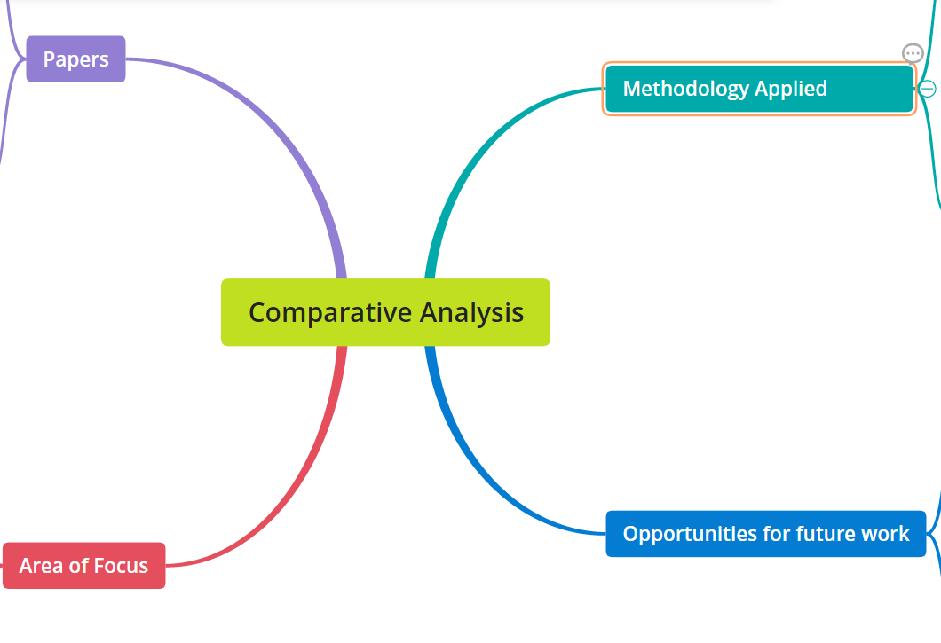
Figure 3.1 Comparative Analysis topics
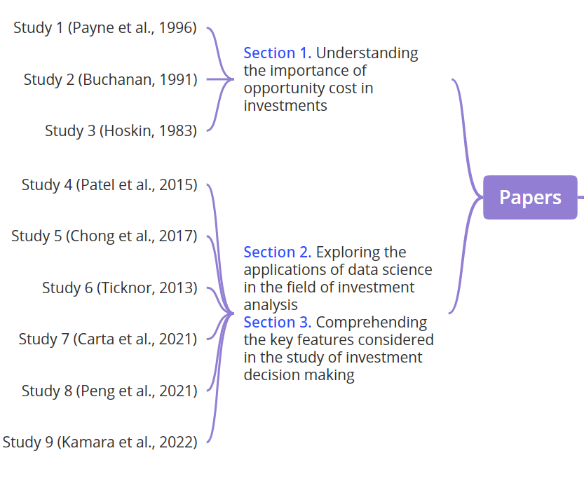
Figure 3.2 Topic 1: Comparisons of Author and Year

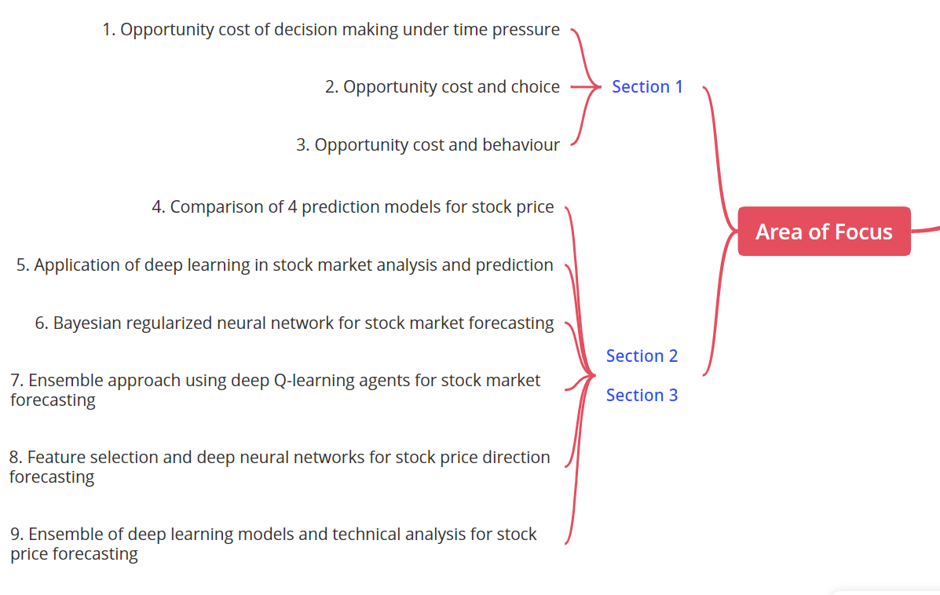
Figure 3.3 Topic 2: Comparing Areas of Focus
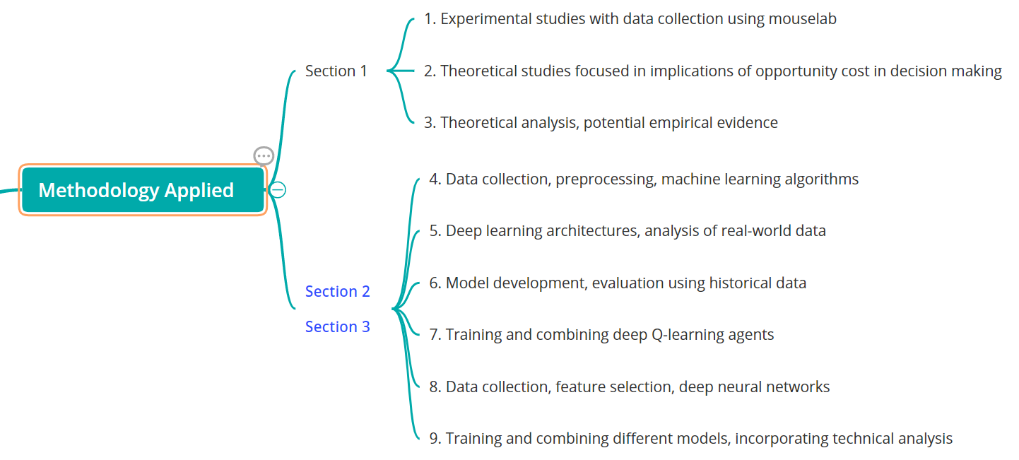
Figure 3.4 Comparing Methodologies applied

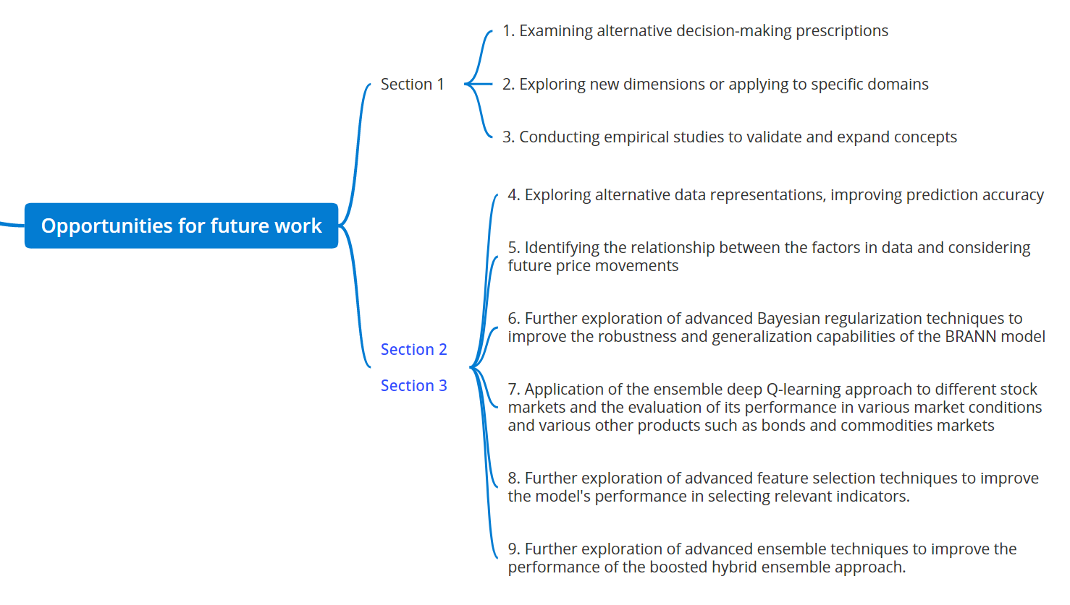
Figure 3.5 Comparing opportunities for future work

4. Conclusion
From this literature review, the analysis reveals that opportunity cost is frequently studied in relation with time, choice and behaviour. Time is one of the factors since allocation of time to various activities and time pressure can impact the perceived value of different choices. Choice becomes another influencing factor since opportunity cost affects decision-making processes particularly in scenarios where multiple choices are available. Behaviour becomes the third influencing factor since individuals perceive and react to opportunity costs, and their biases and heuristics can affect their choices.
The other part of this analysis covers the applications of various machine learning, deep learning and data science techniques in the stock market. It is learnt from the studies in this literature review that these techniques are significantly employed to forecast stock prices.

References
Buchanan, J.M. (1991) “Opportunity cost,” The World of Economics, pp. 520–525. Available at: https://doi.org/10.1007/978-1-349-21315-3_69.
Carta, S. et al. (2021) “Multi-DQN: An ensemble of deep Q-learning agents for stock market forecasting,” Expert Systems with Applications, 164, p. 113820. Available at: https://doi.org/10.1016/j.eswa.2020.113820.
Chong, E., Han, C. and Park, F.C. (2017) “Deep Learning Networks for Stock Market Analysis and prediction: Methodology, Data Representations, and case studies,” Expert Systems with Applications, 83, pp. 187–205. Available at: https://doi.org/10.1016/j.eswa.2017.04.030.
Hoskin, R.E. (1983) “Opportunity cost and behavior,” Journal of Accounting Research, 21(1), p. 78. Available at: https://doi.org/10.2307/2490937.
Kamara, A.F., Chen, E. and Pan, Z. (2022) “An ensemble of a boosted hybrid of deep learning models and technical analysis for forecasting stock prices,” Information Sciences, 594, pp. 1–19. Available at: https://doi.org/10.1016/j.ins.2022.02.015.
Patel, J. et al. (2015) “Predicting stock and stock price index movement using trend deterministic data preparation and machine learning techniques,” Expert Systems with Applications, 42(1), pp. 259–268. Available at: https://doi.org/10.1016/j.eswa.2014.07.040.
Payne, J.W., Bettman, J.R. and Luce, M.F. (1996) “When time is money: Decision behavior under opportunity-cost time pressure,” Organizational Behavior and Human Decision Processes, 66(2). Available at: https://doi.org/10.1006/obhd.1996.0044.
Peng, Y. et al. (2021) “Feature selection and deep neural networks for stock price direction forecasting using technical analysis indicators,” Machine Learning with Applications, 5, p. 100060. Available at: https://doi.org/10.1016/j.mlwa.2021.100060.
Ticknor, J.L. (2013) “A Bayesian Regularized Artificial Neural Network for Stock Market Forecasting,” Expert Systems with Applications, 40(14), pp. 5501–5506. Available at: https://doi.org/10.1016/j.eswa.2013.04.013.

